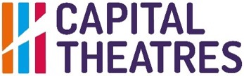
PRESS RELEASE
Immediate Release
20 January 2023

35 DAYS TO SAVE THE KING’S!
AS EDINBURGH LOSES OUT ON UK GOVERNMENT’S LEVELLING UP FUNDING, CAPITAL THEATRES IS WORKING WITH THE SCOTTISH GOVERNMENT, CITY OF EDINBURGH COUNCIL AND THE UK GOVERNMENT TO ENSURE THE KING’S THEATRE DOESN’T CLOSE ITS DOORS FOREVER

- City of Edinburgh Council’s bid to the UK Government’s Levelling Up Fund has been unsuccessful. This grant would have been a crucial contribution towards the funding gap for the King’s Redevelopment project caused by inflation, global conflict and changing trade routes.
- Capital Theatres, the charity which runs the King’s, has already raised £26m and must find the remaining £8.9m in the next 35 days, in time to sign over the building to the contractors, stay on track with the project, and avoid spiralling costs.
- The King’s is vital for the UK’s cultural ecology and is an important heritage community asset that brings significant social and economic benefits to Scotland’s capital city and beyond.
- If the money is not found, Capital Theatres cannot proceed with the redevelopment and will have to hand the keys back to City of Edinburgh Council who own the building.
- Without the redevelopment this Grade A listed building risks closing its doors for good. We are now working with the Scottish Government, City of Edinburgh Council and the UK Government to find this vital funding.

As reported at the end of August 2022, when the King’s Theatre closed in preparation for its transformational redevelopment, a funding gap has placed the King’s future in peril. £26 million has been successfully fundraised by Capital Theatres, but inflation, global conflict and changing trading agreements means that the project will cost an estimated £8.9m more.

If this money is not found before the building is due to be signed over to the contractors in 35 days, we will not be able to keep the project on track and costs will spiral. The King’s could close its doors forever and the city will lose an essential venue and a vital cultural hub for its communities.

Funding from public bodies and generous donations have helped to get us this far but we now need increased support from statutory funders, Scottish Government, the City of Edinburgh Council and the UK Government to see this project over the line.

Fiona Gibson CEO of Capital Theatres said:

“This really is the last chance saloon for the King’s.

It’s been a long road planning and fundraising for the capital redevelopment of the King’s Theatre to turn it into both a thriving community hub, fully accessible to audiences and performers, and a world class venue, while maintaining its history and heritage. Nearly all the original capital cost estimate of £26 million to transform the King’s is in place thanks to grants from the Scottish Government, City of Edinburgh Council and the National Lottery Heritage Fund; generous donations from our patrons and donors, companies and trusts; as well as Capital Theatres’ own contribution. We are incredibly proud of the collective effort to reach this figure.

However, as with all construction projects in the UK currently, we are facing new challenges because of delays in supply chain caused by changing trading agreements, global conflict and increasing levels of inflation. Due to these factors, it has emerged in the last few months that the project costs will increase by an estimated £8.9m. We’ve examined our options and we cannot reduce the project cost any further by value engineering and to delay the redevelopment could lead to even higher costs in the long-term, putting the entire project at risk. If the money is not found in the next few weeks, the last opportunity for us to greenlight the project, the King’s could close its doors forever.

We know what a difficult time this is to be asking for additional funding with so much financial need in every area of civic life, but as custodians of this beloved theatre, we have to fight for its survival.

From the moment the funding gap emerged we have been in close contact and working with key funders including the Scottish Government, City of Edinburgh Council and the UK Government. We need their support to deliver this transformative redevelopment for Tollcross, Edinburgh and Scottish Theatre, ensuring the King’s Theatre is there for generations to come.”

Culture and Communities Convener Cllr Val Walker said: “While we’re disappointed not to have been successful in this round of the Levelling Up fund, we look forward to continuing dialogue and exploring any opportunities open to help secure the future of the Kings Theatre.”

Brian Cox, Honorary Patron of the King’s Theatre said:
“The King’s is vital to the Scottish Theatre ecology and a key touring venue which brings a variety of genres to the central belt; not to mention a source of comfort and joy in panto season. Without the planned transformational redevelopment improving access, preserving heritage and opening the building up to the community, the King’s will close its doors forever. After a hugely successful fundraising effort to reach the original budgeted cost of £26 million, we cannot let the rising costs due to inflation, trade agreements and global conflict put the project in peril. We must save the King’s for future generations.”

This video encapsulates how vital the King’s is for Edinburgh and Scotland’s cultural capital, the city’s identity and heritage and the Tollcross community.
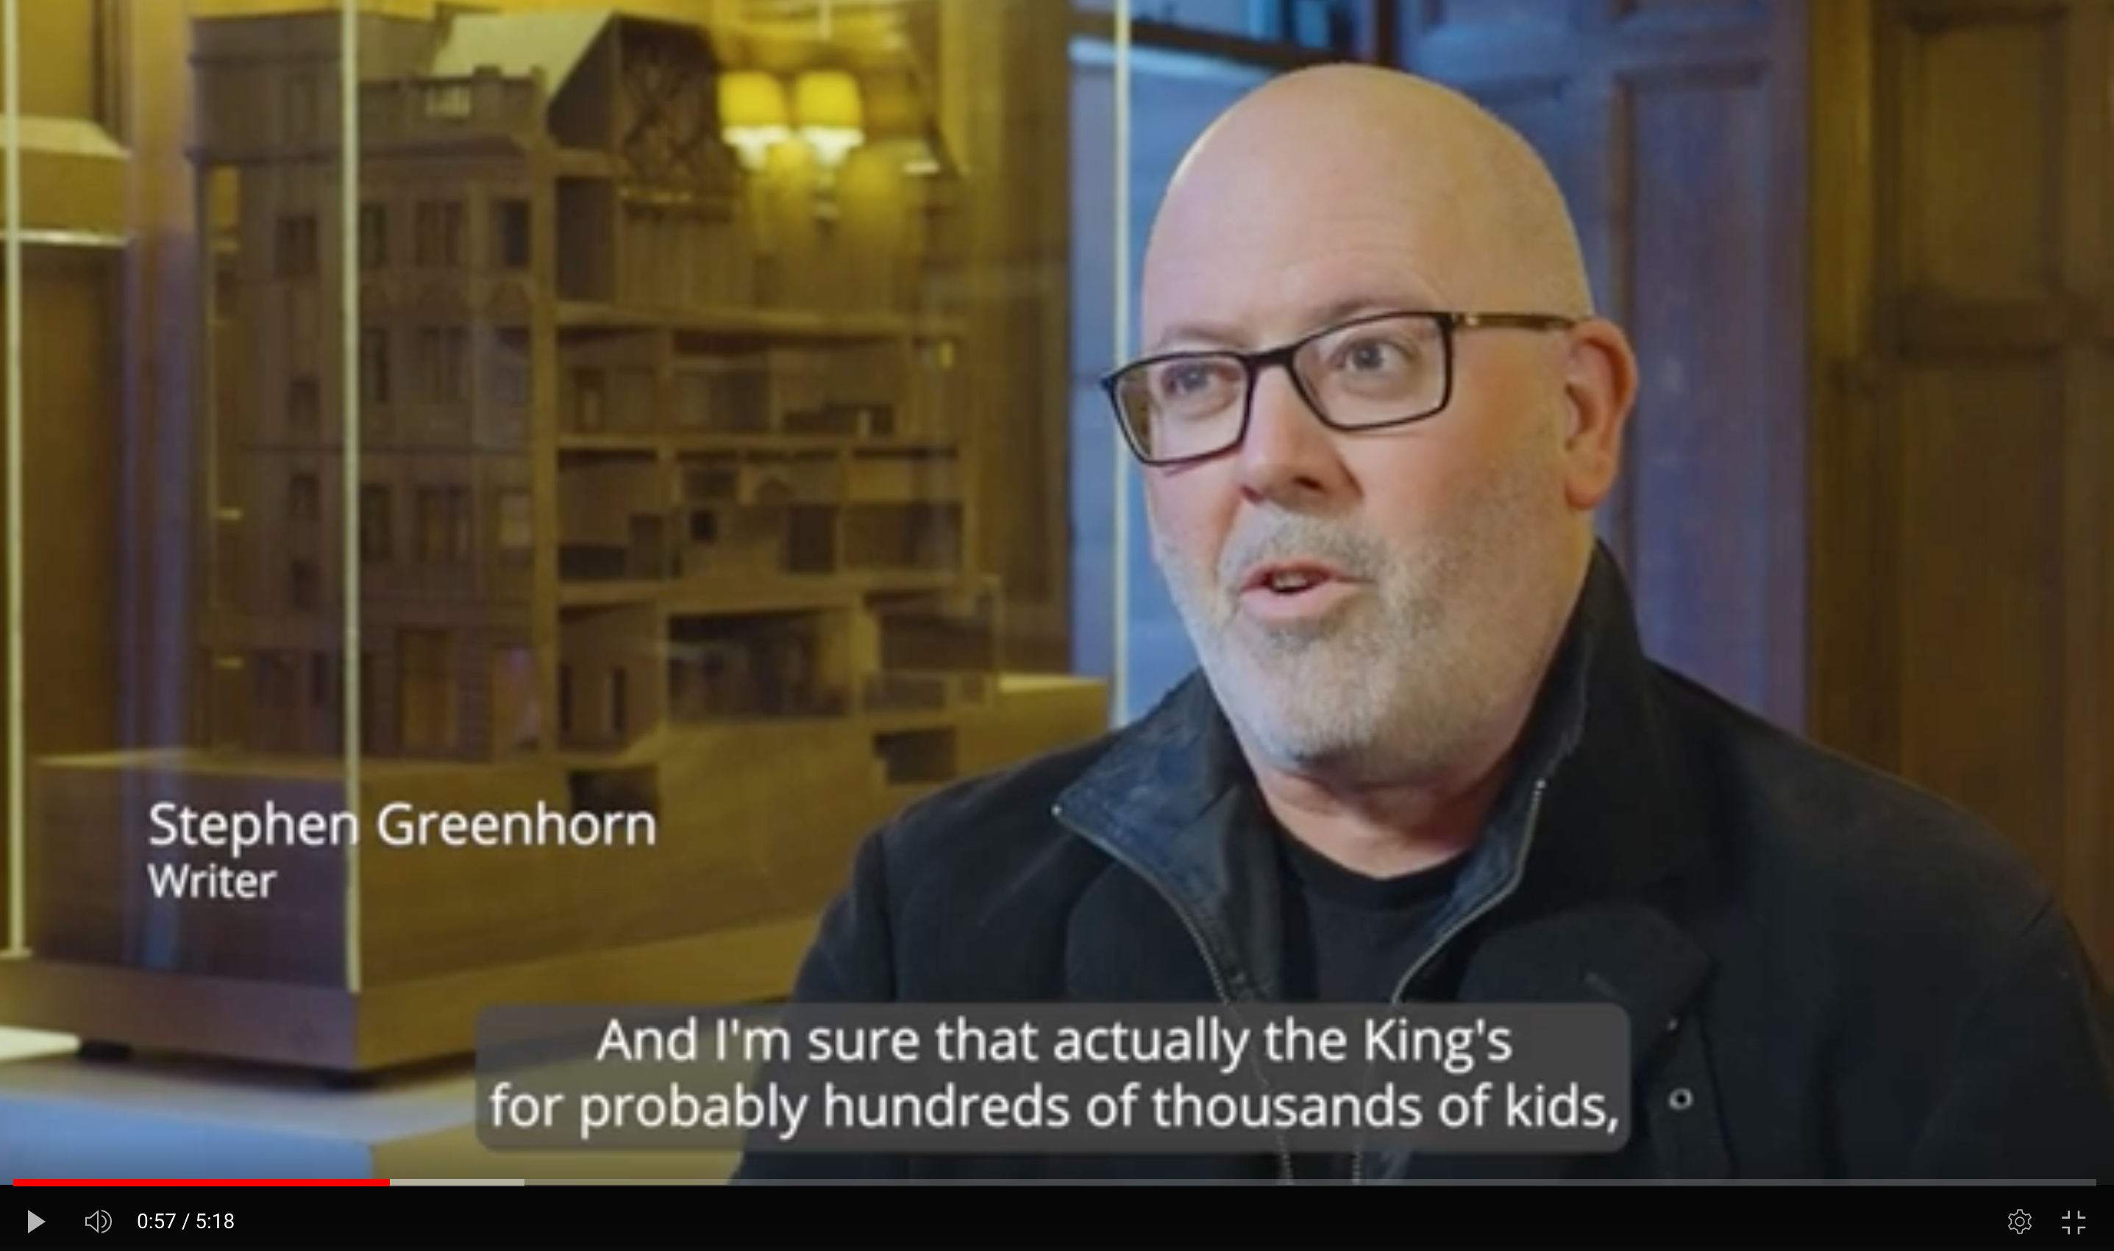

Advocates featured include:
Fergus Linehan, Festival Director 2014 - 2022 of the Edinburgh International Festival said:
"There wouldn't be an International Festival if there wasn't a King's Theatre, because it is here that so many of the signature moments of the Festival have taken place. We want to make sure that our premier theatre space in the city is appropriate for the way theatre, dance and opera tours now, and ensure they don't leapfrog over Edinburgh. As a city and a country we must invest in The King's. Any responsible cultural sector must both make sure the next season is coming, but also to think 10, 20 years down the line to ensure that what we've enjoyed will still be there in the future."

Lynn Brand, Head Teacher of Tollcross Primary School said:
“The King’s is a significant landmark for Tollcross and it’s very much part of our community, and it’s very much oor King’s theatre.”

Stephen Greenhorn, playwright and creator of River City said:
“The King’s for me was my first experience of live theatre at the King’s Panto... and I’m sure that the King’s, for hundreds of thousands of kids by now, is their first experience of live theatre. I don’t think people will realise what it brought to the city until it’s gone.”

Elizabeth Newman, Artistic Director of Pitlochry Festival Theatre said:
“If the King’s redevelopment didn’t go ahead it would be a profound loss to Scottish Theatre but more than that to the nation’s audiences. It has to go ahead, it has to be here, and it has to be modernised.”

Charlotte Fabien, long-term attender said:
“I am one hundred years old and have always come to the King’s, now please support the King’s so the next generation can enjoy it as well.”

Robert Softley Gale, Artistic Director of Birds of Paradise Theatre Company which promotes the work of disabled artists said:
“The redevelopment of the King’s is so important because it means that more disabled people can experience live theatre, but also put their work on in that venue and can be part of Scottish culture in a really important way.”

Tommy Sheppard, MP said:
“It’s a real nightmare to think that this place might close and be turned into some kind of yuppie flats which is the last thing we need, and all this wonderful facility that’s been here for so many decades, and could be here for so many decades more, would be lost. We can’t lose it.”

Sarah Boyack MSP said:
“We cannot contemplate the loss of the King’s, the refurbishment has to go ahead so it’s accessible, it’s brought to life and future generations and visitors to Edinburgh can enjoy the Kings going forward.”

Capital Theatres is incredibly grateful for all the support received so far from so many generous supporters. If members of the public wonder what they can do to help save the King’s, they can write to their MP, MSPs and City of Edinburgh Councillors telling them why they love the King’s and call for this wonderful theatre to be saved. Learn more at www.capitaltheatres.com/kings-future/
DOWNLOAD PICTURES AND VIDEO HERE
ENDS
For more information / interview requests please contact: Sarah Cockburn
Head of Communications and Digital, Capital Theatres, sarah.cockburn@capitaltheatres.com / 07736461940

Notes to Editors

The King’s Redevelopment
The funding model for the King’s Redevelopment comprises of grants from the Scottish Government (£6.5m), City of Edinburgh Council (£4m), National Lottery Heritage Fund (£3.6m) and £3.1m raised from patrons and donors, companies and trusts. Capital Theatres is contributing £4.4 million and has negotiated a prudential loan to allow the charity to reach £26.7m, vs the original estimated project cost of £25.7m. However, we now find ourselves with a significant funding shortfall due to project duration, complex buildability requirements, global events leading to supply chain issues, inflation and cost of living impacts. As a result the cost is now £35.6m and the charity must secure £8.9 million to close the funding gap.

Capital Theatres
Capital Theatres presents world-class shows to entertain and inspire audiences of all ages.
Our three venues; Festival Theatre (1,915 seats), King’s Theatre (1,300 seats) and The Studio (155 seats) host over 700 performances each year with a broad and inclusive programme featuring the very best in drama, dance, musical theatre, live music, comedy and pantomime.
In the last year alone we have staged a series of co-productions including James IV - Queen of the Fight, Sunshine on Leith and festive early years commissions, including, The Enormous Christmas Turnip, and The Gift and The Unexpected Gift with Barrowland Ballet, an inclusive piece for young people with complex needs. Our new artist development strand is being piloted called Open@The Studio.

Much of our programme is exclusive to our venues in Scotland, providing the only opportunity for audiences to see the biggest shows touring north of the border, the best in international contemporary dance and the latest productions from leading local and national companies.
We support access to the arts for everyone and have an extensive creative engagement programme of talks, workshops and events to introduce and develop engagement and interest in the heritage of our buildings and all areas of live performance.

We are a registered Scottish charity (SC018605) and our theatres and our programme are supported by the City of Edinburgh Council.
www.capitaltheatres.com

